Test Project

Web Technologies

Speed Test

Submitted by:

Thomas Seng Hin Mak WS

Marcelo Strehl BR

Seunglyul Ryu KR

Abraham Quesada CR

Ilya Belyakov RU

Chorng-Shiuh Koong TW

Manuel Schaffner CH

Siew Hwa Kang SG

Zoltan Sisak HU

# Contents

1. Contents 3
2. Introduction 4
3. Part A: Website Design 5
   1. A1: Blur Picture Image (Easy) 5
   2. A3: Pattern (Easy) 5
   3. A5: Walking Gif (Normal) 5
4. Part B: Layout 6
   1. B3 Loading Screen (Normal) 6
   2. B4 Toggle (Normal) 6
5. Part C: Front-End Development 6
   1. C15: Parallax (Normal) 6
   2. C16: Smiley (Normal) 6
6. Part D: Back-End Development 7
   1. D5: Watermark (Easy) 7
   2. D6: Predominant colors (Easy) 7
   3. D11: A Pagination Code (Nromal) 7
7. Part E: Content Management Systems 8
   1. E1: Animated Social Button Plugin (Normal) 8
   2. E4: Plugin works (Easy) 9
   3. E10: Installing Wordpress (Easy) 9
8. Instructions to the Competitor 10
9. Marking Scheme 10

# Introduction

In this module, you are given 3 hours to complete mini tasks. There are 5 parts of mini tasks, they are design, layout, front-end development, back-end development and content management system.

You do not need to do all of the mini tasks. You will received instruction on which tasks that is required during competition.

# Part A: Website Design

## A1: Blur Picture Image (Easy)

Given a picture image, please use graphical software to make this on greyscale, put a blur effect, and save as a1.jpg.

## A3: Pattern (Easy)

Make a background image with any line pattern that repeat every 100x100 pixels, and save with 1920x1080 px as result.jpg.

## A5: Walking Gif (Normal)

Create a GIF animation from the given walk.gif file, so that the character moves in from the left edge of image and moves right and moves out of the right edge of screen.

# Part B: Layout

## B3 Loading Screen (Normal)

Create an animated loader using only HTML and CSS same as video.mp4. The loader animation should be looped. 4 different colors (#19A68C, #F63D3A, #FDA543, #193B48) should be used.

Screen shots:

   

## B4 Toggle (Normal)

To create an IOS Toggle switch using HTML and CSS only. View video for animation details.

|  |  |
| --- | --- |
|  |  |

# Part C: Front-End Development

## C15: Parallax (Normal)

Adjust the background parallax depending on the position of the mouse cursor (the closer the objects are to the user, the faster they move).

## C16: Smiley (Normal)

Create a big smiley face on the center of the page. It is 400px wide, and rectangular. Below the smiley, there are 3 buttons with texts: “:)”, “:|”, and” :(“. By clicking the buttons the smiley face changes to that state with a 0.5s animation. By default the smiley is in “:|” state. The states have these designs:

# Part D: Back-End Development

## D5: Watermark (Easy)

Put a watermark (png file) on the image provided. The watermark should be in the lower right corner.

## D6: Predominant colors (Easy)

Identify the 3 predominant colors in the provided image and show them.

## D11: A Pagination Code (Nromal)

After reading data.json, the data in the current page must be shown..

5 data must be shown in one page.

5 page links to move to another page must be shown in one page

Create buttons to move 5 pages at once, previous and next.

Page link of current page must be located in the center

Take a look at the provided screen shots and data.json.

You can only use HTML & CSS & PHP, but for reading json data and the pagination code must use only PHP. You can use bootstrap and JavaScript is not allowed.

Screen shots:

example1example2example3

# Part E: Content Management Systems

## E1: Animated Social Button Plugin (Normal)

Create social buttons plugin for Wordpress using Fontawesome icons and add hover effects for the buttons.

When the plugin activated, social buttons must be shown in the footer area.

There should be 4 social buttons and the icon fonts are below.

facebook - <i class="fab fa-facebook-f"></i>

pinterest - <i class="fab fa-pinterest"></i>

twitter - <i class="fab fa-twitter"></i>

thumblr - <i class="fab fa-tumblr"></i>

The color of hover effects are below.

facebook - #3d5998

pinterest - #e50122

twitter - #54acec

thumblr - #314258

The effects should be same with thie example video but you can change the duration time of the hover effects.

You can only use HTML and CSS, no JS(including Libries and Framewors) are allowed.

Screen Shots(See the video.mp4 in folder named “2”)

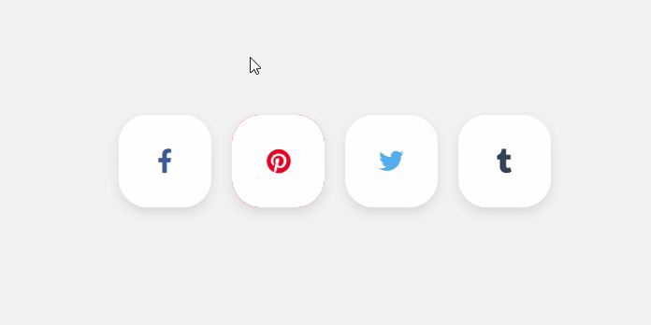

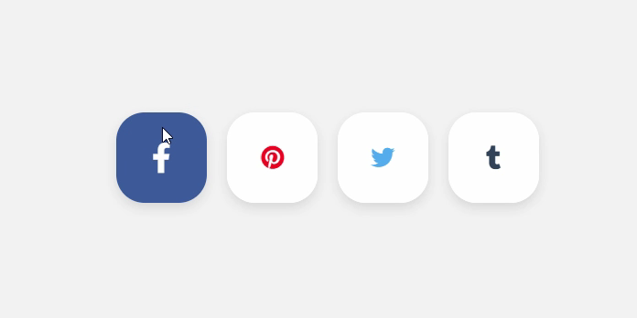

## E4: Plugin works (Easy)

- Make a plugin that when activated, insert a new menu item on admin, and when accessed, shows a Title: "Plugin works!";

## E10: Installing Wordpress (Easy)

Now a client needs a wordpress blog to go up and live very quickly. They don’t care about the layout so default theme should work. But they want to have a “Steelblue” top bar and “Light Cyan” background color on their blog. Please install a new wordpress website with the following requirement:

* Title: Handy Cafe
* Sub-title: A cafe that you never forget.
* Top color bar on all page: 5 px steel blue
* Background color on all page: light cyan
* Categories: products, closing time, events
* There are menus on home page that links to posts listing of the mentioned categories.

# Instructions to the Competitor

You do not need to implement all the tasks. There will be instruction on C1 to clarify which tasks are selected to be implemented.

# Marking Scheme

|  |  |  |  |  |
| --- | --- | --- | --- | --- |
| Section | CRiterion | judgement marks | measurement marks | total |
| A1 | Design | 0 | 2 | 2 |
| A2 | Layout | 0 | 2 | 2 |
| A3 | Front-end | 0 | 2 | 2 |
| A4 | Back-end | 0 | 2 | 2 |
| A5 | CMS | 0 | 2 | 2 |